Заказчик/Customer |  |  |  |  | Aeroflot |  | Номер заказа/№ пп /  RO/Item № |  |  |  |  | R49069626
Черт. номер компонента:/  P/N: |  |  |  |  | D2557216001800 |  | Карта-наряд / WSS
Сер. или внутр. номер:/ S/N or internal No: |  |  |  |  | 101500324 |  | Плановая трудоёмкость  Planned MHRS |  |  |  |  | 11 MHRS
Статус/Вид работ  Status/Work |  |  | Инспекция/проверка  Inspection/Check ☒ |  |  | Ремонт /  Repair ☐ |  |  |  |  | Капремонт /  Overhaul ☐ |  |  | Модификация /  Modification ☐
Подготовил/Prepared by: |  |  |  |  |  |  |  |  | Утвердил/Approved by
Дата/Date |  |  |  | ФИО/Name |  |  |  |  | Дата/Date |  |  |  | ФИО/Name
17.02.2026 |  |  |  | I. Beliakov |  |  |  |  | 17.02.2026 |  |  |  | S. Gorbachev
Детали и материалы / Parts and Materials:
No | Описание / Description |  |  |  |  |  |  | Чертёжный номер / Part Number |  |  |  |  |  |  | Кол-во / Qty
 | Solvent (MEK, Isopropyl Alcohol 99% or equivalent) |  |  |  |  |  |  | N/A |  |  |  |  |  |  | A/R
 | Textile-Lint free cotton |  |  |  |  |  |  | 14SBA1 or equivalent |  |  |  |  |  |  | A/R
Оборудование и инструменты / Equipment & Tools:
No | Описание / Description |  |  |  |  |  |  |  |  | Чертёжный номер / Part Number
 | NDT Tool |  |  |  |  |  |  |  |  | Olympus 600
Ссылка на ЭД /  Doc. reference: |  | AIRBUS A320: CMM 25-59-63, NTM 51-10-08.

-
Технология выполнения / Accomplishment instructions
ОЧИСТКА / CLEANING
Item | IAW CMM TASK 25-59-63-100-801-A01 | Исп./ Mech. | Инсп./ Insp.
Refer to 25-59-63-100-001-A01 Cleaning of the Painted Component Parts
A. Cleaning of the Painted Component Parts
(1) Remove the loose dirt with a vacuum cleaner or a soft brush.
(2) Remove the remaining sealant and dirt with a nonmetallic scraper.
(3) Clean the component parts with Solvent and a soft brush or the Material No. 14SBA1 Textile-Lint free Cotton.
(4) Remove the detergent with clean water.
(5) Dry the component parts with a clean, dry Material No. 14SBA1 Textile-Lint free Cotton - or a hot-air blower.
Item | IAW CMM TASK 25-59-63-100-802-A01 | Исп./ Mech. | Инсп./ Insp.
Refer to Subtask 25-59-63-100-002-A01 Cleaning of the Component Parts which are not Painted.
A. Cleaning of the Component Parts which are not Painted
(1) Remove the loose dirt with a vacuum cleaner or a soft brush.
(2) Remove the remaining dirt with a nonmetallic scraper.
(3) Clean the component parts with the Material No. 08BBF1 Non Aqueous Cleaner- Methyl-Ethyl-Ketone - and a soft brush or the Material No. 14SBA1 Textile-Lint free Cotton.
(4) Dry the component parts with a clean, dry Material No. 14SBA1 Textile-Lint free Cotton - or a hot-air blower.
ИНСПЕКЦИЯ / INSPECTION/CHECK
Item | IAW CMM TASK 25-59-63-010-801-A01 | Исп./ Mech. | Инсп./ Insp.
- Remove the Ball Units IAW CMM task 25-59-63-010-801-A01 and FIGURE 2 for inspection.
  - Put the pins of the Ball Units Wrench into the holes of the upper cover of the ball units. Refer to Figure 2.
  - Push the attachment pins against the spring pressure and remove the ball units from the ball mat/ball strip assembly.
- Clean the ball units, if necessary.
- Perform Visual Inspection open hole of place install ball unit. If found corrosion or other damage, mark all found deviations on Figure 1-7 and record details in Table 1.
Item | IAW CMM TASK 25-59-63-210-801-A01 | Исп./ Mech. | Инсп./ Insp.
Check of the Metal and GFRP Components of the Ball Mats for Cracks.
NOTE: If you think there is a crack, you must do an approved nondestructive test.
If a metal component has a crack:
- Replace the component (See the DISASSEMBLY and ASSEMBLY sections of CMM 25-59-63).
Item | NDT Hight frequents eddy current inspection IAW NDT 51-10-08 | Исп./ Mech. | Инсп./ Insp.
 |  | NDT
If REQUIRED, perform NDT Hight frequents eddy current inspection
Note: Perform HFECI for cracks only when suspected cracks area detected through visually inspection.
Perform a Hight frequents eddy current inspection to confirmed crack refer to NTM 51-10-08
NDT report №:___________________________________
Item | IAW CMM TASK 25-59-63-210-801-A01 | Исп./ Mech. | Инсп./ Insp.
Check of the Metal and GFRP Components of the Ball Mats for Scratches.
1 If the surface of the metal component has a scratch:
a. Repair the scratch (See REPAIR TASK 25-59-63-300-802-A01).
b. When the scratch is fully removed, measure the dimensions of the
repair:
-A maximum repair length of 25.0 mm (0.984 in) is permitted.
-A maximum repair depth of 0.25 mm (0.0098 in) is permitted.
2 If the GFRP has a scratch:
- Install a patch for damage that is more than 6.0 mm (0.2362 in),
- see the REPAIR TASK 25-59-63-300-804-A01.
- Replace the component (See REPAIR TASK 25-59-63-350-806-A01):
- If the patch will overlap an adjacent repair
- If the patch edge distance is less than 25.4 mm (1.0 in)
Item | IAW CMM TASK 25-59-63-210-801-A01 | Исп./ Mech. | Инсп./ Insp.
Check of the Metal and GFRP Components of the Ball Mats for Marks.
1 If the surface of the component has a mark:
a. Repair the mark (See REPAIR TASK 25-59-63-300-801-A01).
b. When the mark is fully removed, measure the dimensions of the repair:
-A maximum repair depth of 0.25 mm (0.0098 in) is permitted.
-A maximum repair area of 150.0 mm² (0.2325 in²) is permitted.
c. Measure the distance between the repair and an adjacent repair (if applicable):
-The distance between the edges of two adjacent repairs must be more than 50.0 mm (1.969 in).
- Replace the components, if their repair dimensions or the distance between repairs are not in the limits (See the DISASSEMBLY and ASSEMBLY sections of CMM 25-59-63).
Item | IAW TASK 25-59-63-210-801-A01 | Исп./ Mech. | Инсп./ Insp.
Check of the Metal and GFRP Components of the Ball Mats for Corrosion.
1 If the metal component has corrosion:
a. Repair the corrosion (See REPAIR TASK 25-59-63-300-801-A01).
b. When the corrosion is fully removed, measure the maximum
depth of the repair:
-A maximum repair depth of 0.25 mm (0.0098 in) in all areas is permitted.
-A maximum repair area of 150.0 mm² (0.2325 in²) is permitted.
c. Replace the components, if their repair dimensions are not in the limits (See the DISASSEMBLY and ASSEMBLY sections of CMM 25-59-63).
2 If there corrosion between the GFRP and the metal component:
- Install a patch for damage that is more than 6.0 mm (0.2362 in),
- see the REPAIR TASK 25-59-63-300-804-A01of CMM 25-59-63.
- Replace the component (See REPAIR TASK 25-59-63-350-806-A01 of CMM 25-59-63):
- If the patch will overlap an adjacent repair
- If the patch edge distance is less than 25.4 mm (1.0 in).
Item | IAW CMM TASK 25-59-63-210-801-A01 | Исп./ Mech. | Инсп./ Insp.
Check of the Metal and GFRP Components of the Ball Mats for Debonding.
1 If the GFRP component is debonded:
a. Install a patch, see the REPAIR TASK 25-59-63-300-804-A01 of CMM 25-59-63.
b. Replace the component (See REPAIR TASK 25-59-63-350-806-A01 of CMM 25-59-63):
-If the patch will overlap an adjacent repair
-If the patch edge distance is less than 25.4 mm (1.0 in).
Item | IAW CMM TASK 25-59-63-210-801-A01 | Исп./ Mech. | Инсп./ Insp.
Check of the Metal and GFRP Components of the Ball Mats for Damaged protective treatment.
1 If the protective treatment of the component is damaged:
-Repair the protective treatment (See REPAIR TASK 25-59-63-300-803-A01 of CMM 25-59-63).
Item | Check of the Ball Units IAW CMM TASK 25-59-63-210-802-A01 | Исп./ Mech. | Инсп./ Insp.
- Examine the ball units for general condition.
(2) Replace the ball units which are not in a good condition (see DISASSEMBLY TASK 25-59-63-010-801-A01 and ASSEMBLY TASK 25-59-63-410-801-A01 of CMM 25-59-63).
Item | Check of the Sealing Tape IAW CMM TASK 25-59-63-210-803-A01 | Исп./ Mech. | Инсп./ Insp.
(1) Examine the sealing tape for:
- Debonding
- Cracks
- Oil contamination
- Porosity
- Hardness.
(a) If a sealing tape has signs of debonding, cracks, oil contamination, porosity or hardness:
- Replace the sealing tape (See REPAIR TASK 25-59-63-350-803-A01 of CMM 25-59-63).
Item | Check of the Captive Screw IAW CMM TASK 25-59-63-210-805-A01 | Исп./ Mech. | Инсп./ Insp.
(1) Examine the captive screw for:
- Operation mode
- Corrosion.
(a) Operation Mode
1 If a captive screw has no operation mode:
a) Replace the defective captive screw (See REPAIR TASK 25-59-63-350-801-A01 of CMM 25-59-63).
(b) Corrosion
1 If a captive screw has corrosion:
a) Replace the defective captive screw (See REPAIR TASK 25-59-63-350-801-A01 of CMM 25-59-63).
Item | Result IAW CMM TASK 25-59-63-210-801-A01 | Исп./ Mech. | Инсп./ Insp.
14.
Are any damages found?
YES________/ NO_______
If damages found - Mark all found deviations on Figure 1 and record details in Table 1.
ЗАКЛЮЧИТЕЛЬНЫЕ ДЕЙСТВИЯ / FINAL ACTION
Item | Close up the inspection card | Исп./ Mech. | Инсп./ Insp.
15.
Specify a revision of manual:
CMM 25-59-63, Rev.: ____ Date:_______________
2. (If Required) remarks:

Технология выполнения / Accomplishment instructions
Фигура 1/Figure 1
Определение зоны / Zone definition
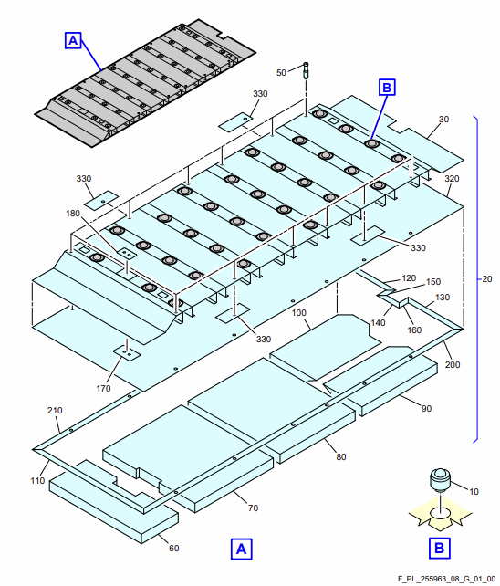

Figure 08G / CMM 25-59-63-950-808-G01

Фигура 2/Figure 2

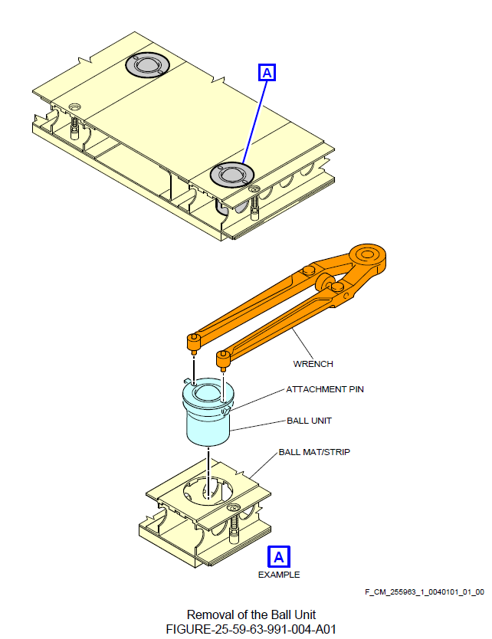

CMM FIGURE 25-59-63-991-004-A01

Фигура 3/Figure 3

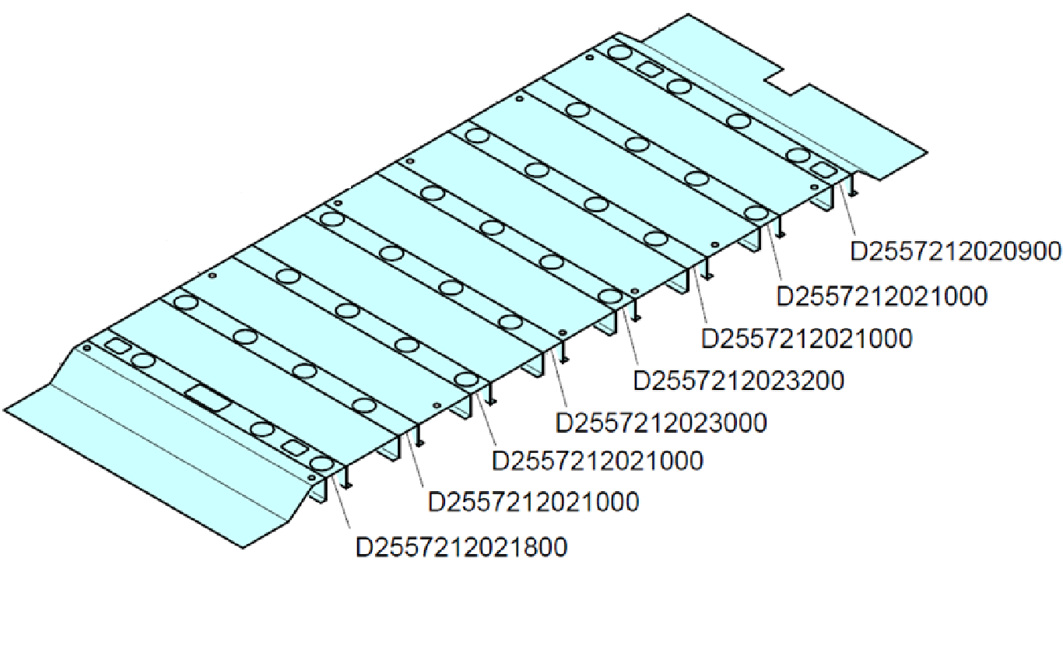
Ball Mat P/N
D2557216001800

Figure 72 / CMM 25-59-63-950-872-01

Таблица/Table 1
Обнаруженные неисправности / Finding List
№ позиции на рисунке/ Item # on Figure 1 | Описание неисправности/ повреждения / Description finding /damage | Размеры неисправности/ повреждения (Длина, Ширина, Глубина) /  Damage size (Length Width Depth) (in or mm) | Возможность устранения неисправности/повреждения согласно применимой ЭД (да/нет) / Can be rectification iaw maintenance data (yes/no)

Фактическая трудоемкость/ Actual MHRS |  | Все работы выполнены/All tasks accomplished
 |  | Дата/Date | ФИО/Name | Подпись и ID или штамп / Signature & ID number or stamp

